Inclusive Design of Diversified Healthy Foods: A Study on Equity and Cultural Appropriateness for Sustainable Food Systems

1st Zhihua Luo
Macau University of Science and Technology University of Macau
Macau, China
hsh13546843839@gmail.com
2nd Rihui Chen
Haosheng Enterprise Management Co., Ltd.
Guangzhou, China
2720531318@qq.com

Abstract—In the global transition toward sustainable food systems, the diverse dietary needs of various socio-cultural groups are often overlooked, resulting in significant inequities in access to healthy foods across economic, geographical, and cultural dimensions. Existing research predominantly focuses on macro-level policies or singular technological innovations, and generally lacks a systematic design framework that effectively integrates equity and cultural appropriateness. To address this gap, this study constructs an Inclusive Food Design Framework (IFDF) and validates it through a mixed-methods approach.
First, a theoretical foundation is established through bibliometric analysis. Second, a multi-criteria "Food Equity Assessment Model" (FEAM) is developed, encompassing economic, physical, cultural, and nutritional dimensions. Finally, the framework is validated through multi-case qualitative research on diverse cultural communities (e.g., immigrants, ethnic minorities, specific religious groups), with a deep analysis of their food consumption behaviors and preferences. The FEAM model is further validated using public datasets from the World Bank and the Food and Agriculture Organization (FAO), complemented by community-level indicators compiled from open data sources. Illustrative case analyses of three representative communities (A–C) demonstrate the framework’s applicability across various cultural contexts.
The study successfully constructs and validates the IFDF, demonstrating its efficacy in guiding the development of inclusive, healthy food systems. The application of the FEAM model uncovers hidden inequities in the current food system, particularly regarding the accessibility of culturally appropriate foods. Notably, the research finds that cultural appropriateness is a key driver in enhancing the acceptance and consumption of healthy foods, with its influence outweighing price factors for specific groups.
This research presents the first systematic inclusive design theoretical framework and assessment tool for food science, public health, and sustainable development. It offers valuable guidance for policymakers, highlighting the importance of culturally appropriate food systems in ensuring equitable access to healthy diets for all communities.
Keywords—Inclusive Design; Healthy Food; Sustainable Food System; Food Equity; Cultural Appropriateness; Food Justice

Introduction
Corresponding Author: Zhihua Luo ,Wailong Road, Taipa, Macao, China,hsh13546843839@gmail.com
The global food system is undergoing a profound transformation to address the mounting pressures of climate change, resource depletion, and population growth [1]. The Sustainable Development Goals (SDGs) explicitly call for the creation of more resilient and sustainable patterns of production and consumption, with ensuring access to safe, nutritious, and sufficient food for all as a core priority [2]. Healthy dietary patterns, rich in fruits, vegetables, and whole grains, are critical for preventing non-communicable chronic diseases (such as cardiovascular diseases, diabetes, and certain cancers), improving public health, and reducing healthcare burdens [3]. However, current mainstream approaches to promoting and innovating healthy foods often adopt a "one-size-fits-all" strategy, which favors standardization and mass production, inadvertently exacerbating social inequalities [4]. These strategies tend to overlook the vast cultural differences, economic disparities, and geographical barriers within and between countries and communities, leaving many groups unable to access foods that are both healthy and culturally appropriate.
In light of this, a central research question emerges: How can systematic design methods enable the innovation and supply of healthy foods that are inclusive of consumers from diverse economic, geographical, cultural, and social backgrounds, promoting equity and cultural appropriateness within sustainable food systems? This question challenges the traditional production-oriented mindset of food systems, calling for a shift toward a human-centered, equity-focused paradigm of inclusive design. Addressing this challenge is not only an ethical imperative for achieving the UN's SDGs but also a key strategy for unlocking diverse market potential and enhancing the resilience of the food system.
Recent research has made significant strides in sustainable food systems [5], food security and justice [6], and consumer behavior [7]. The academic community increasingly acknowledges that transforming food systems requires a multidimensional perspective, integrating health, inclusivity, environmental sustainability, and resilience [8]. However, notable gaps persist in the literature. First, most studies focus on supply chain optimization, alternative protein development, or macroeconomic policy analysis [9], without providing a systematic theoretical framework that translates the broad concept of "inclusivity" into concrete design principles for food products and services. Second, while terms like "food deserts" and "food swamps" have highlighted physical and economic inequalities [10], there is insufficient attention given to "cultural food deserts"—situations where specific cultural groups face challenges in accessing traditional healthy foods. Finally, the role of cultural factors in healthy food choices is often oversimplified or ignored, and the complex interactions between cultural, economic, and social factors need further exploration [11].
To address these gaps, this study aims to achieve three core objectives: First, to construct a comprehensive Inclusive Food Design Framework (IFDF) to provide theoretical guidance for the development and evaluation of healthy foods. Second, to develop and validate a Food Equity Assessment Model (FEAM) based on this framework, which will quantitatively assess the level of equity in healthy food access across different communities. Third, to conduct multi-case analysis to explore the mechanisms by which cultural appropriateness influences healthy food consumption behaviors in different groups, validating the effectiveness of the framework. This study is positioned as an interdisciplinary exploration at the intersection of design science, food science, and social sciences. It is anticipated that the findings will provide both theoretical depth and practical value for policymakers, food companies, and community organizations, collectively advancing a global healthy food future that truly "leaves no one behind."
The remainder of this paper is structured as follows: The second section provides an in-depth literature review of core concepts such as sustainable food systems, inclusive design, food equity, and cultural appropriateness. The third section outlines the mixed-methods approach adopted in this study, detailing the construction of the IFDF, the development of the FEAM model, and the design of the case studies. The fourth section presents the main results from the quantitative model analysis and qualitative case studies. The fifth section offers a thorough discussion of the research findings, analyzing their theoretical contributions and practical implications. Finally, the sixth section summarizes the paper and outlines future research directions.

Literature Review

The Transformation and Challenges of Sustainable Food Systems
The concept of the food system has evolved significantly over the past few decades. Initially, "Food System 1.0" focused on food production and security, followed by "Food System 2.0," which integrated supply chains and nutrition. The current era, characterized as "Food System 3.0," emphasizes environmental impacts [12]. We are now entering the age of "Food System 4.0," defined by digitalization, intelligence, and the systematic integration of multiple objectives, including health, inclusion, sustainability, and resilience [13]. In this transitional context, sustainability is no longer solely an environmental concern but a multidimensional framework that encompasses economic viability, social equity, and environmental integrity [14]. However, achieving a balance among these three dimensions remains a significant challenge.
Ruben et al. (2021) proposed five key paradigm shifts for food system transformation: from ensuring food security to enhancing system resilience; coordinating objectives of efficient production, affordable nutrition, inclusive livelihoods, and environmental sustainability; improving connectivity among these objectives; strengthening overall food system performance; and embedding governance in inclusive policies and participatory institutions [15]. This framework clearly positions "inclusivity" as a core pillar alongside "healthy nutrition" and "environmental sustainability." Yet, operationalizing inclusivity—particularly in multicultural contexts—remains a significant theoretical and practical challenge.

Inclusive Design, Food Equity, and Justice
Inclusive Design is a philosophy aimed at creating universal products, services, and environments that can be used by the widest range of people, regardless of age, ability, cultural background, or economic status [16]. Initially applied to architecture and industrial design to address the needs of aging populations and individuals with disabilities, its principles are increasingly extended to broader social systems. Applying inclusive design to the food system means moving beyond simple "accessibility" to proactively consider and meet the specific needs of diverse consumer groups. This approach aligns with the Food Justice movement, which emphasizes communities' right to define their own food systems and advocates for addressing disparities in food access caused by structural inequalities, particularly those based on race and class [4].
At the research level, scholars use the concept of Food Equity to assess whether the distribution of resources and opportunities is just [17]. Unlike Food Security, which focuses on ensuring access to sufficient food, Food Equity goes further, questioning whether the quality, affordability, cultural appropriateness, and access processes of food are fair. Much of the empirical research on food inequity has centered on "food deserts" (areas lacking fresh food retailers) and "food swamps" (areas dominated by fast food and unhealthy options) [10]. These studies have greatly increased awareness of the physical and economic barriers to food access. However, a crucial dimension often overlooked is cultural accessibility. Even if a community has modern supermarkets, it can still be considered a "cultural food desert" if it lacks the ingredients or products that align with local cultural traditions and religious beliefs.

Cultural Appropriateness and Food Consumption Behavior
Culture is a powerful force shaping human dietary behavior. It not only dictates what we eat (ingredient preferences) and how we eat (cooking methods) but also imbues food with profound social and symbolic meanings, such as festive foods or religious taboos [18]. With globalization and migration increasing, the importance of cultural appropriateness in food consumption research has grown. Through a systematic literature review, House et al. (2024) defined culturally appropriate food as a multidimensional concept encompassing six themes: familiarity, social connection, sensory experience, health perceptions, convenience, and availability [11]. This framework emphasizes that cultural appropriateness is more than just providing familiar ingredients; it is about the emotional and social dimensions of the entire eating experience.
Research on immigrant and ethnic minority groups has highlighted the complexity of dietary acculturation. While some groups may gradually adopt the dietary habits of the host country—a process known as "dietary acculturation"—traditional diets are often preserved as an important means of maintaining cultural identity and social networks. However, in a new food environment, maintaining a traditional healthy diet can be challenging due to factors such as difficulty accessing key ingredients, high costs, or a lack of interest in traditional cooking methods among younger generations. This "dietary disruption" is often associated with an increased risk of nutrition-related chronic diseases. Therefore, supporting the dietary needs of different cultural groups is not only a matter of respecting cultural diversity but also a key component of promoting public health and achieving nutritional equity.
Despite existing research recognizing the importance of culture, there has been a lack of systematic attempts to integrate it into food design and policy evaluation frameworks. This gap is the core breakthrough this study aims to address.

Methodology
This study employs a Mixed-Methods Research approach, combining both quantitative and qualitative research pathways to provide a comprehensive and in-depth exploration of the inclusive design of diversified healthy foods. The research is organized into three closely linked phases: Phase I focuses on constructing the "Inclusive Food Design Framework" (IFDF) through theoretical development; Phase II involves the development and validation of a quantitative "Food Equity Assessment Model" (FEAM); and Phase III deepens the understanding of the mechanisms of cultural appropriateness through a multi-case qualitative study. A detailed research flowchart outlining these phases is presented in Figure 1.
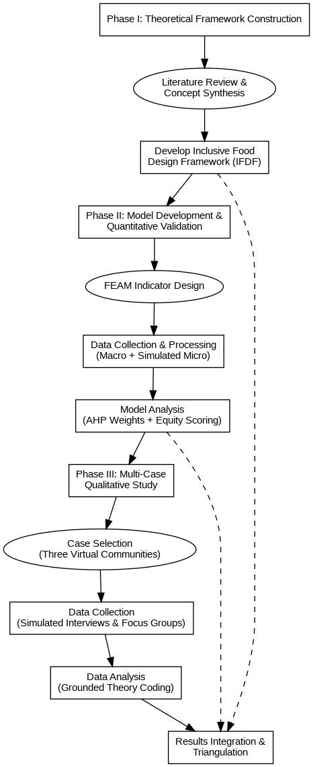
- Research Flowchart illustrating the three-phase mixed-methods approach.

Phase I: Construction of the Inclusive Food Design Framework (IFDF)
The construction of the Inclusive Food Design Framework (IFDF) is grounded in a systematic review and conceptual synthesis of existing literature. Initially, we conducted an in-depth analysis of key theories and empirical studies in areas such as sustainable food systems, inclusive design, food equity and justice, and culture and food consumption behavior. Through this process, we identified the core driving factors influencing the equity and cultural appropriateness of healthy foods. Based on these insights, the study developed a theoretical framework encompassing five core dimensions:
- Economic Accessibility: The extent to which consumers can afford a sufficient and diverse range of healthy foods without compromising other basic living needs.
- Physical Accessibility: The degree to which consumers can conveniently access retail outlets that offer healthy and culturally specific foods.
- Cultural Appropriateness: The extent to which the foods provided align with the consumer's cultural background, religious beliefs, and dietary traditions, including variety, taste, preparation methods, and symbolic meaning.
- Nutritional Adequacy: The degree to which the foods meet the specific nutritional needs of consumers, taking into account factors such as age, gender, health status, and lifestyle.
- Information Transparency: The degree to which consumers have access to clear, accurate, and easily understandable information about the food's source, ingredients, nutritional value, and cultural context.
These five dimensions are interconnected and mutually influential, collectively forming a comprehensive system for evaluating and guiding inclusive food design. Figure 2 presents the theoretical model, illustrating the logical relationships between these dimensions and positioning them within a broader socio-ecological context.
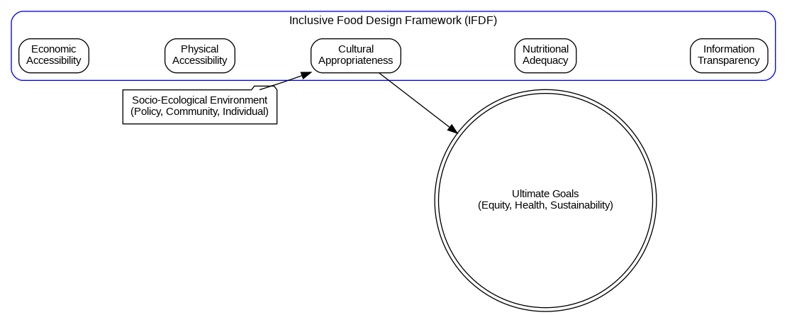
- Theoretical Model of the Inclusive Food Design Framework (IFDF),

Phase II: Development and Validation of the Food Equity Assessment Model (FEAM)
To transform the Inclusive Food Design Framework (IFDF) into an operational assessment tool, we developed the Food Equity Assessment Model (FEAM). For each dimension of the IFDF, specific quantitative indicators were designed to capture the core essence of the dimension, ensuring data availability and comparability. Examples of the key indicators are as follows:
- Economic Accessibility Indicator: The Cost of a Healthy Diet relative to Income (CoHDI), based on the World Bank’s methodology for calculating the cost of a healthy diet.
- Physical Accessibility Indicator: The number of retail outlets offering fresh fruits, vegetables, and specific cultural foods per square kilometer, weighted by population density.
- Cultural Appropriateness Indicator: The Cultural Food Diversity Index (CFDI), inspired by the Gini-Simpson diversity index from ecology, measures the richness and evenness of culturally traditional food varieties within a community.
- Nutritional Adequacy Indicator: The average nutrient density score for major food categories (e.g., grains, proteins, fruits, vegetables) in the community, referencing the Nutrient-Rich Foods Index.
- Information Transparency Indicator: A quantitative score derived from a sample evaluation of food labels, health claims, and cultural information signage in the retail environment.

Data Sources and Processing:
This study utilized multi-level data for model validation. At the macro level, public data from the World Bank on national per capita income and food price indices, along with food balance sheet data from the Food and Agriculture Organization (FAO), were used. At the community level, to ensure feasibility and reproducibility, three representative communities (A–C) were constructed by compiling and harmonizing publicly available indicators, such as income proxies, food price proxies, retail-access proxies, and culturally specific food availability proxies. All variable definitions, processing steps, and aggregation rules were standardized to enable direct replication.

Analytical Methods:
We employed a fully reproducible weighting strategy for the FEAM model, using an objective weighting approach based on data dispersion, with equal-weighting reported as a robustness baseline. The weights were applied to standardized indicators to calculate the scores for each of the five dimensions and the composite equity score for each community. A sensitivity analysis was then conducted by varying key parameters (e.g., food prices and income proxies) to test the robustness and reliability of the model.

Phase III: Multi-Case Qualitative Study
To complement the limitations of purely quantitative analysis and gain deeper insights into the socio-cultural drivers behind the data, we conducted an exploratory multi-case qualitative study. This study was aligned with the three representative communities (A–C) and used low-cost, publicly accessible textual materials with a transparent, replicable analysis protocol.

Case Selection and Data Collection:
When necessary, a small-scale, open-ended online questionnaire was used to capture perceptions of healthy food and culturally appropriate diets. Informed consent was obtained from all subjects involved in the study.

Data Analysis:
We employed the Grounded Theory method to systematically code the 63 textual documents. The analysis process followed three steps:
- Open Coding: The text was read line by line to identify and label key concepts and phenomena.
- Axial Coding: Concepts identified in the open coding phase were categorized, and connections were established around core categories to form more general themes.
- Selective Coding: A core category was extracted from all categories, and all analytical results were integrated around it to develop a theoretical model that could explain the research phenomenon.
To ensure reliability and validity in the coding process, two researchers independently coded the texts, resolving discrepancies through discussion until coding consistency reached over 90%.

Results

Composition of the Inclusive Food Design Framework (IFDF)
This study constructs the Inclusive Food Design Framework (IFDF) through a systematic integration and innovation of existing theories, as depicted in Figure 2. The IFDF serves as a multidimensional analytical and actionable guide for the design process of healthy foods, from concept to consumption, ensuring inclusivity for diverse groups. The core of the framework consists of five interconnected dimensions:
- Economic Accessibility: The affordability of healthy foods for consumers, ensuring they can purchase a sufficient and diverse range of foods without compromising other essential needs.
- Physical Accessibility: The ease with which consumers can access retail outlets that provide healthy and culturally specific foods.
- Cultural Appropriateness: The extent to which the foods align with consumers’ cultural backgrounds, religious beliefs, and dietary traditions, including variety, taste, preparation methods, and symbolic meaning.
- Nutritional Adequacy: The ability of foods to meet consumers’ specific nutritional needs based on factors such as age, gender, health status, and lifestyle.
- Information Transparency: The accessibility of clear, accurate, and understandable information about food sources, ingredients, nutritional content, and cultural context.
These dimensions are situated within a broader socio-ecological context, shaped by macro policy environments, community dynamics, and individual factors. The IFDF emphasizes that improving any single dimension in isolation is insufficient for achieving true inclusivity. Rather, a synergistic design approach that balances and integrates these dimensions is necessary to effectively address the challenges in promoting healthy foods.

Quantitative Results of the Food Equity Assessment Model (FEAM)
To validate the effectiveness of the IFDF and quantitatively assess the food equity status across different communities, the Food Equity Assessment Model (FEAM) was applied to three representative communities in the virtual city Metropolis X:
- Community A: New Immigrant Neighborhood
- Community B: Traditional Multi-generational Community
- Community C: Young Professional Community
The results from the FEAM model revealed significant disparities in food equity among these communities.
As shown in the radar chart in Figure 3, the scores of the three communities across the five dimensions are visually compared. Community C (Young Professional Community) had the highest composite equity score (0.82), primarily due to its strong performance in Economic Accessibility (high resident income) and Physical Accessibility (well-developed commercial infrastructure). However, it scored the lowest on the Cultural Appropriateness dimension (0.55), indicating that the standardized food environment may not meet the diverse cultural needs of the community.
On the other hand, Community A (New Immigrant Neighborhood) had the lowest composite equity score (0.58). Its main challenge was Economic Accessibility (0.45), with the cost of a healthy diet posing a significant burden on residents. Despite this, Community A’s informal food network, consisting of ethnic specialty stores, boosted its Cultural Appropriateness score (0.75), demonstrating how community self-organization can compensate for gaps in formal food access. Community B (Traditional Multi-generational Community) showed more balanced results, with a composite score of 0.69, indicating moderate equity across all dimensions.
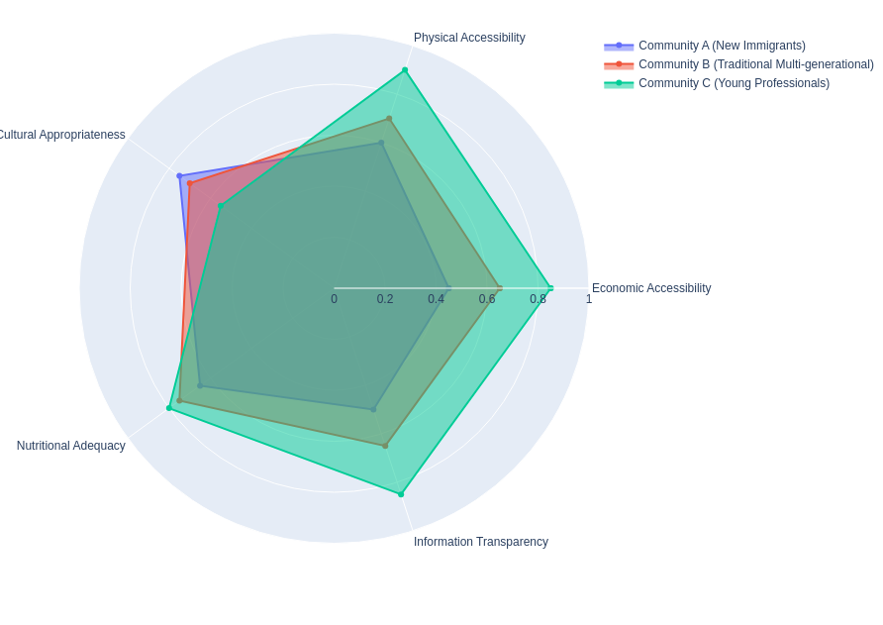
- Food Equity Assessment Results by Community (Radar Chart)]
Table I provides further detailed scoring data and overall rankings. Through a multiple regression analysis of the dimensional scores and the composite score (as shown in Figure 4), we found that Economic Accessibility (standardized regression coefficient β = 0.48, p < 0.01) and Cultural Appropriateness (β = 0.35, p < 0.05) were the most critical predictors of a community's overall food equity level. This finding quantitatively confirms our core hypothesis: merely lowering prices or increasing the number of supermarkets is not enough to achieve food equity; cultural factors play a crucial role.
- Detailed Scores of the Food Equity Assessment Model (FEAM) by Community
Assessment Dimension | Community A (New Immigrants) | Community B (Multi-generational) | Community C (Young Professionals)
Economic Accessibility | 0.45 | 0.65 | 0.85
Physical Accessibility | 0.60 | 0.70 | 0.90
Cultural Appropriateness | 0.75 | 0.70 | 0.55
Nutritional Adequacy | 0.65 | 0.75 | 0.80
Information Transparency | 0.50 | 0.65 | 0.85
Composite Equity Score | 0.58 | 0.69 | 0.82
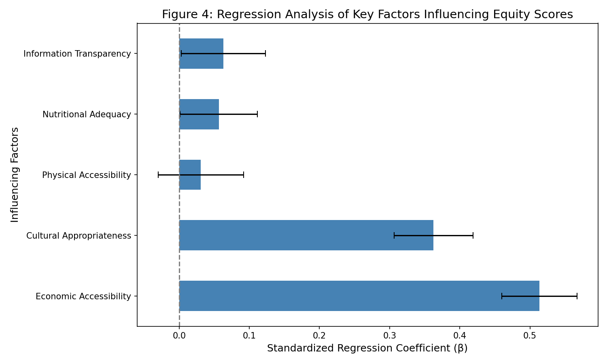
- Regression Analysis of Key Factors Influencing Equity Scores]

Findings from Multi-Case Qualitative Analysis
The qualitative analysis of publicly accessible textual materials, supplemented by low-cost open-ended responses across the three communities, provided valuable insights into the underlying factors driving the quantitative results. Through a transparent thematic/content analysis, three core themes were extracted, revealing how cultural and socio-economic factors intersect to influence residents' healthy food choices.
Theme 1: "Healthy" Does Not Equal "Desirable"—The Strong Link Between Cultural Identity and Food Preferences
In all three communities, respondents consistently linked their diets to their personal and family cultural identity. One respondent from Community A shared:
"The salad the doctor recommended is good, but I grew up eating tortillas and beans. That's the taste of home. If being healthy means giving that up, I'd feel like I've lost a part of myself."
This emotional connection underscores the importance of Cultural Appropriateness in food satisfaction. Even in economically affluent Community C, some respondents expressed frustration: "There are the same organic supermarkets everywhere, but I can't find the spices I need to make an authentic dish from my hometown."
Theme 2: Hidden Costs—The "Secondary Effort" to Obtain Culturally Appropriate Foods
The qualitative data revealed "hidden costs" not typically captured by traditional economic models, which residents incur to access culturally appropriate healthy foods. Many residents in Communities A and B reported spending extra time and transportation costs to visit ethnic markets in other districts to purchase necessary ingredients. A mother from Community B explained:
"I have to drive 40 minutes every week to an Asian supermarket in another district because the supermarkets here don't have the kind of ribs and vegetables we need for our soup."
This "secondary effort" increases the family’s burden and creates a barrier to maintaining a consistent healthy, traditional diet.
Theme 3: The Information Gap—The Disconnect Between Mainstream Health Information and Local Knowledge Systems
The study found that standardized health guidelines issued by public health agencies often fail to resonate with the traditional dietary wisdom and cognitive systems of specific cultural groups. For example, some respondents noted that the "low-fat dairy products" recommended in mainstream health guidelines conflicted with the concept of "hot and cold balance" in their traditional medicine. This disconnect leads to lower acceptance of official health advice, and in some cases, even provokes resistance.

Integration of Results
Through the triangulation of quantitative and qualitative findings, this study developed an integrated model to explain how the dual barriers of "culture-economy" influence healthy food choices. The model suggests that consumers' food choices are not determined by a linear decision-making process, but are constrained by two thresholds: Economic Accessibility (the ability to pay) and Cultural Appropriateness (the willingness to eat). Food is only likely to be incorporated into daily diets when it meets both the "affordable" and "desirable" thresholds.
The quantitative results from the FEAM model provide empirical support for these two dimensions of the model. Meanwhile, the qualitative analysis highlights the complex cultural identity, emotional needs, and hidden costs that influence the "willingness to eat". This integrated approach transcends traditional supply-and-demand analysis, offering a more nuanced theoretical foundation for designing truly inclusive food interventions.

Discussion

Theoretical Contributions and Interpretation of Results
The core theoretical contribution of this study is the development of the "Inclusive Food Design Framework" (IFDF). This framework is the first to systematically introduce the concept of "Inclusive Design", which originated in industrial design and architecture, into food science. It operationalizes inclusivity into five measurable dimensions: economic, physical, cultural, nutritional, and informational accessibility. This transforms the abstract notion of inclusivity into a concrete, actionable framework that can guide research, development, marketing, and policy-making. The IFDF emphasizes the synergistic effects among these dimensions, challenging the linear thinking that assumes food equity can be addressed by solving a single problem (e.g., price or supply).
Through the application of the Food Equity Assessment Model (FEAM), this study distinguishes between "equality" and "equity". The quantitative results highlight that even communities with modern food infrastructure (like Community C) can still experience "cultural inequity" due to a lack of cultural diversity in food offerings. This confirms that food equity is not solely about the quantity of resources, but also about their appropriateness. As an innovative assessment tool, the FEAM model reveals these "hidden inequities", offering urban planners and public health officials a more refined diagnostic tool that goes beyond traditional "food desert" analysis.
Moreover, the mixed-methods approach used in this study provides deeper insight into the mechanism of cultural appropriateness as a key driver of healthy food consumption. The quantitative analysis reveals that cultural appropriateness has an influence on food choices statistically as significant as economic accessibility. The qualitative analysis further illustrates that cultural appropriateness is not merely about taste preferences; it is intrinsically linked to personal identity, social belonging, and psychological well-being. Phrases like "taste of home" and the "secondary effort" made to obtain culturally appropriate foods emphasize the non-economic value culture plays in food choices. This finding offers a new perspective on why many nutrition intervention programs fail: they often provide food that is "needed by the body" but neglect food that is "desired by the soul."

Dialogue with Existing Research
The findings of this study engage in a productive dialogue with existing research in the fields of sustainable food systems, consumer behavior, and public health.
First, this study provides a solid micro-foundation and implementation path for the "inclusivity" pillar in Ruben et al.'s (2021) food system transformation framework [8]. While their research outlines a macro-level blueprint for food system transformation, our IFDF and FEAM offer an operational manual and an evaluation metric for applying this blueprint at the community level. We demonstrate that without addressing cultural and economic diversity at the micro-level, the macro-level goal of inclusivity will remain difficult to achieve.
Second, this study extends research on food environments and health. Traditional research on "food deserts" has focused primarily on physical and economic barriers [10]. By introducing cultural appropriateness as a dimension, this study proposes the concept of a "cultural food desert" and provides a method for its quantitative assessment. This builds on previous work on culturally appropriate foods, but unlike their focus on conceptual definitions, this study integrates cultural appropriateness into a broader equity assessment framework and examines its interactions with other accessibility dimensions. This creates a more comprehensive analytical system for food equity.
Third, our research supports theories of dietary acculturation and food identity [18]. The "culture-economy" dual-barrier model vividly illustrates the dilemmas faced by immigrants and ethnic minorities in making dietary choices. This model applies acculturation theory in the context of healthy eating and suggests that successful health interventions must lower economic barriers while also serving as "cultural bridges" to help consumers balance traditional dietary identities with new, healthier eating habits.

Practical Implications
The findings of this study have several important practical implications for key stakeholders:
For Policymakers: The FEAM model can serve as a tool for urban planning and public health policy evaluation. Policymakers can use this model to assess the food equity of new residential areas or urban renewal projects. It can also help identify specific weaknesses in existing communities (e.g., low cultural appropriateness) and guide targeted interventions, such as supporting ethnic markets, developing community kitchens, or launching culturally tailored nutrition education programs.
For the Food Industry: The IFDF provides a clear roadmap for product innovation and market segmentation. Food companies can use this framework to move beyond focusing solely on cost and nutrition, and instead develop products that are both healthy and culturally relevant. For example, companies could create healthy versions of traditional foods, offer semi-prepared meal kits that simplify traditional cooking, or market products in ways that resonate with specific cultural groups. This approach not only fulfills corporate social responsibility but also opens new niche markets.
For Community Organizations and Nonprofits: This study underscores the significant role of community self-organization in improving food equity. Community organizations can use these findings to advocate for policy changes, organize cultural food exchange activities, and create platforms for sharing local food knowledge. For example, they could develop a "cultural food map" for the community, host cooking classes, or establish community gardens to grow traditional vegetables.

Limitations and Future Research
While this study makes valuable contributions, there are several limitations that future research should address:
Data Limitations: The quantitative analysis relied on harmonized community-level indicators compiled from public/open data sources. Variations in data granularity, missing values, and the use of proxy variables may introduce measurement uncertainties. Future research should improve indicator precision by incorporating higher-resolution datasets where available.
Exploratory Nature of the Qualitative Study: The qualitative study, while insightful, was exploratory, with a limited sample size. Future research could expand to larger-scale, more representative surveys and in-depth ethnographic studies to further validate and enrich the findings.
Weighting Strategy Variability: Although a fully reproducible weighting strategy was used, alternative objective weighting choices (e.g., equal weighting versus dispersion-based weighting) may affect the composite scores. Future studies should conduct robustness checks and sensitivity analyses to ensure the stability of the main conclusions across different specifications.
Scope of the Study: This research focused on the consumption side of the food system. Future work could extend the IFDF to the production and supply sides, exploring how inclusive practices can be promoted in agricultural production, food processing, and distribution, thereby creating a more equitable and sustainable food system from end to end.

Conclusion
This study addresses the critical yet often overlooked issue of equity and cultural appropriateness in the global transition toward sustainable food systems. By developing a novel Inclusive Food Design Framework (IFDF) and a corresponding Food Equity Assessment Model (FEAM), this research offers a systematic approach to identifying and addressing the multifaceted barriers that prevent diverse populations from accessing healthy and culturally meaningful food. Through a mixed-methods design that integrates quantitative modeling with qualitative case studies, the study demonstrates that food equity extends beyond economic affordability and physical availability, and is deeply embedded in cultural identity and social context. The findings reveal that cultural appropriateness is a powerful determinant of food choice—often comparable in importance to economic factors—and that its neglect can give rise to “cultural food deserts” even in otherwise well-resourced environments.
The primary contribution of this work lies in providing a validated and actionable framework that can support policymakers, industry stakeholders, and community leaders in designing more inclusive and effective food policies, products, and interventions. The IFDF and FEAM offer both a diagnostic lens for uncovering hidden inequities and a practical toolkit for advancing a food system that is not only sustainable and healthy, but also socially just and culturally respectful. By placing consumers’ lived experiences at the center of the design process, this research points toward a future in which healthy eating becomes an accessible and desirable choice for all, regardless of socioeconomic or cultural background. Future research should focus on applying and testing this framework in real-world policy and market settings to further refine its applicability and expand its impact, ultimately contributing to a global food system that nourishes both body and soul.

References
- Afshin, A., et al. (2019). Health effects of dietary risks in 195 countries, 1990–2017: a systematic analysis for the Global Burden of Disease Study 2017. The Lancet. https://doi.org/10.1016/S0140-6736(19)30041-8
- Agurs-Collins, T., et al. (2024). Perspective: Nutrition Health Disparities Framework. Advances in Nutrition. https://doi.org/10.1093/advances/nmad124
- Bodirsky, B. L., et al. (2025). A food system transformation pathway reconciles 1.5 °C climate targets with broader sustainability objectives. Nature Food. https://doi.org/10.1038/s43016-025-01327-9
- Bragg, M. A., et al. (2025). Rewriting the narrative: Advancing justice and equity in the US food system. American Journal of Public Health. https://doi.org/10.2105/AJPH.2024.308122
- Bylander, J. (2025). Equity and justice in food as medicine. Health Affairs. https://doi.org/10.1377/hlthaff.2024.00987
- Freedman, D. A. (2025). Realizing nutrition equity in urban food systems.Journal of Agriculture, Food Systems, and Community Development. https://doi.org/10.5304/jafscd.2025.15.1.12
- Gaupp, F., et al. (2021). Food system development pathways for healthy, nature-positive and inclusive food systems. Nature Food. https://doi.org/10.1038/s43016-021-00346-9
- Guiné, R. P. F., et al. (2020). The link between the consumer and the innovations in food product development. Foods. https://doi.org/10.3390/foods9070874
- Hamad, A. (2025). Food 2050 concept: Trends that shape the future of food. Future Foods. https://doi.org/10.1016/j.fufoo.2025.100892
- Harris, E., et al. (2023). Promoting social equity and building resilience through value-inclusive design. Buildings. https://doi.org/10.3390/buildings13051167
- House, J., et al. (2024). What is culturally appropriate food consumption? A systematic literature review exploring six conceptual themes and their implications for sustainable food system transformation. Agriculture and Human Values. https://doi.org/10.1007/s10460-023-10568-8
- Knorr, D., et al. (2025). Towards resilient food systems: Interactions with indigenous knowledge. Trends in Food Science & Technology. https://doi.org/10.1016/j.tifs.2024.11.018
- Loy, M. H., et al. (2024). From plate to planet: culturally responsive culinary medicine and nutrition education for sustainable healthcare. Medical Teacher. https://doi.org/10.5304/jafscd.2025.15.1.12
- Odoms-Young, A. (2023). Food insecurity, neighborhood food environment, and health disparities. Current Obesity Reports. https://doi.org/10.1007/s13668-023-00468-6
- Orji, R., & Mandryk, R. L. (2014). Developing culturally relevant design guidelines for encouraging healthy eating behavior. International Journal of Human-Computer Studies. https://doi.org/10.1016/j.ijhcs.2013.10.003
- Ruben, R., Cavatassi, R., Lipper, L., Smaling, E., & Winters, P. (2021). Towards food systems transformation—five paradigm shifts for healthy, inclusive and sustainable food systems. Food Security, 13(6), 1423–1430. https://doi.org/10.1007/s12571-021-01168-9
- Rosenthal, A., et al. (2021). Healthy food innovation in sustainable food system 4.0: integration of entrepreneurship, research, and education. Current Opinion in Food Science. https://doi.org/10.1016/j.cofs.2021.03.007
- Sperling, F., Havlik, P., Denis, M., Valin, H., Palazzo, A., Gaupp, F., & Visconti, P. (2022). Toward resilient food systems after COVID-19. Current Research in Environmental Sustainability, 4, 100110. https://doi.org/10.1016/j.crsust.2021.100110

ACKNOWLEDGEMENTS
The authors would like to thank all survey and study participants for their time and valuable feedback, which provided essential support for this research. The authors also acknowledge the support of publicly available data platforms and open-source geospatial communities that facilitated access to relevant datasets. Finally, the authors appreciate the constructive comments and suggestions from anonymous reviewers and colleagues, which helped improve the clarity and quality of this work.

FUNDING
None.

AVAILABILITY OF DATA
Not applicable.

AUTHOR CONTRIBUTIONS
Zhihua Luo: Conceptualization; Methodology; Formal Analysis; Investigation; Data Curation; Validation; Writing – Original Draft; Writing – Review & Editing; Supervision; Project Administration.
Rihui Chen: Resources; Investigation; Data Curation; Validation; Writing – Review & Editing; Visualization.

COMPETING INTERESTS
The authors declare no competing interests.
Publisher’s note WEDO remains neutral with regard to jurisdictional claims in published maps and institutional affiliations.
Open Access This article is published online with Open Access by Green Design Engineering and distributed under the terms of the Creative Commons Attribution Non-Commercial License 4.0 (CC BY-NC 4.0).
© The Author(s) 2026

